cd web

hhvm -m server -p 8080

Open the localhost: 8080 host in your browser:

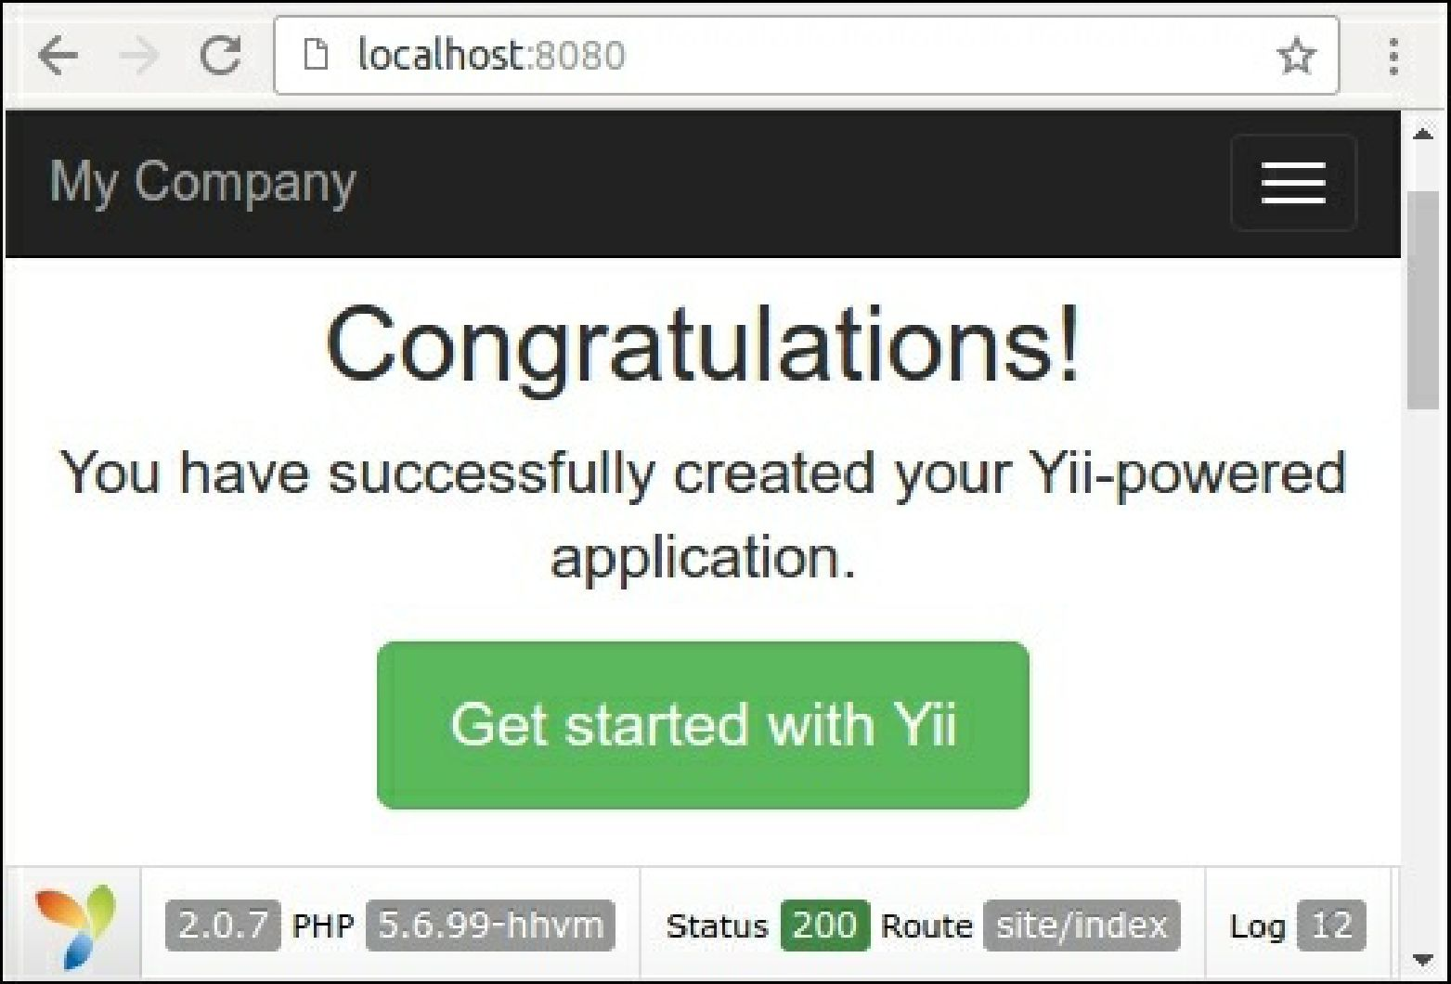

Right now you can use HHVM to develop your project.

4. If you use the Nginx or Apache2 server, then HHVM automatically creates its own configuration files in the /etc/nginx and /etc/apache2 directories. In the case of Nginx, it creates the /etc/nginx/hhvm. conf template to include configuration file to your projects. For example, let’s create a new virtual host called yii-book-hhvm.app:

server {

listen 127.0.0.1:80; server_name .yii-book-hhvm.app; root /var/www/yii-book-hhvm.app/web; charset utf-8;

index index.php index.html index.htm; include /etc/nginx/hhvm.conf;

}

Add the hostname into your /etc/hosts:

127.0.0.1 yii-book-hhvm.app

Now restart the Nginx server:

sudo service nginx restart